**Problems in Automation of Website**

* **Strava :-** The website is protected by reCAPTCHA, which poses a challenge for automation. Additionally, it doesn't provide clear reasons for login failures, making it difficult to determine whether the email doesn't exist or if only the password is incorrect



* **Medium :-** The website doesn't feature any input field for entering the password. After entering the email, it sends a confirmation message to your registered email address. In the case of signing up, it sends an OTP for registration.

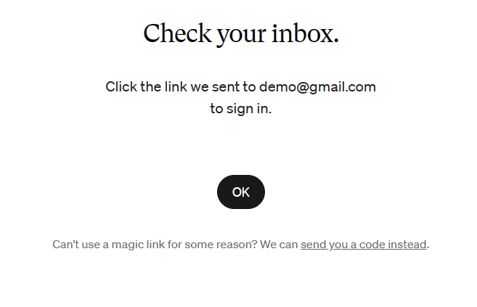

* **Steam :-** This website doesn't have any field for entering an email. To check for the presence of that email on the website, it only has input fields for the account name and password.

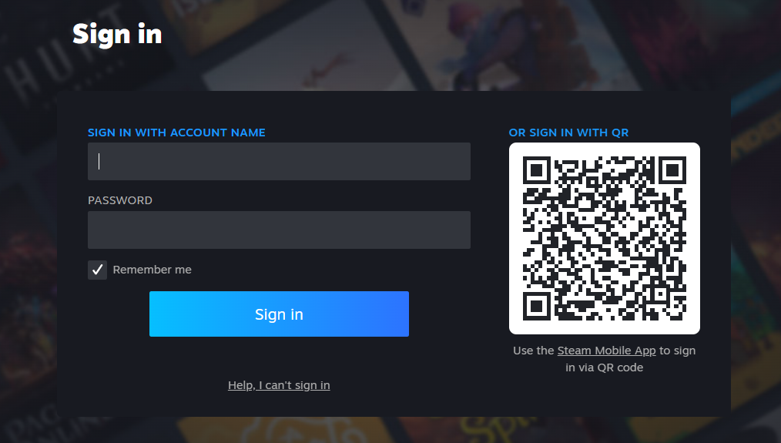

* **Guardian :-** Similar to Stava, the website is protected by reCAPTCHA, which poses a challenge for automation. Furthermore, it lacks clear error messages for login failures, complicating the determination of whether the email doesn't exist or if only the password is incorrect.

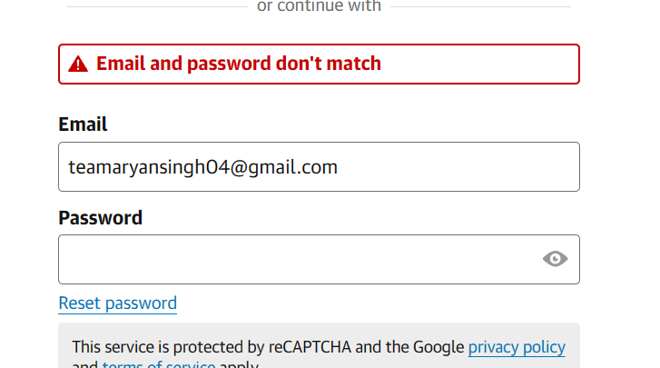

* **Trello :-** This website lacks clear error messages for login failures, complicating the determination of whether the email doesn't exist or if only the password is incorrect.

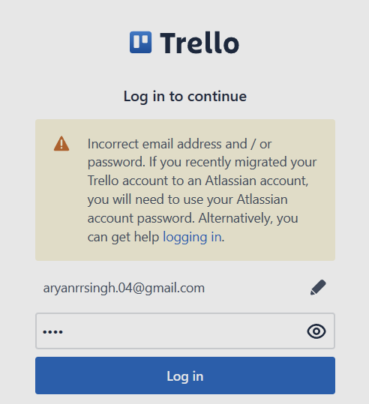

* **New-York Times :-** When opening the website through Selenium WebDriver, it presents a CAPTCHA for solving.

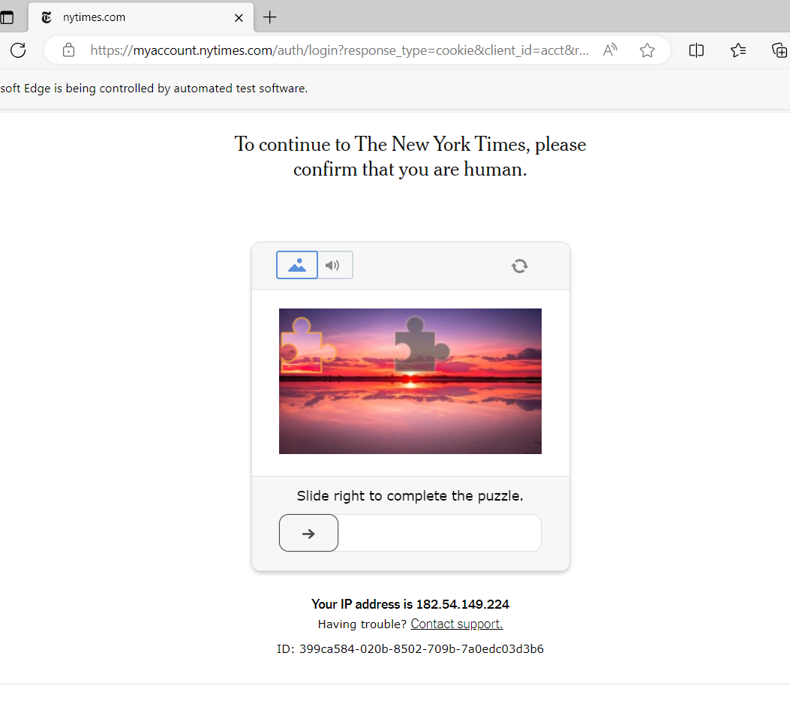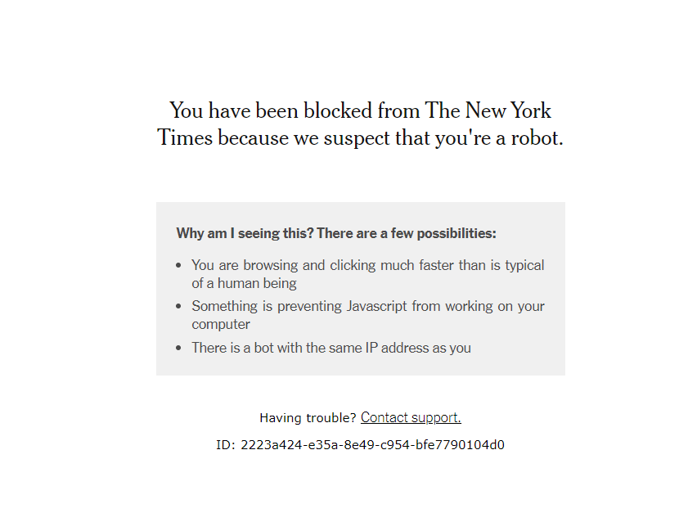

* **Youtube :-** When logging into YouTube with a Gmail account, it passes through Google services. Since other domain accounts aren't accepted, Gmail accounts are automatically registered on YouTube due to this integration. When users create a Gmail account, they gain access to YouTube via Google services. Therefore, every Gmail account is registered on YouTube.
* **Coinbase :**- The website is protected by reCAPTCHA, which poses a challenge for automation. Additionally, it doesn't provide clear reasons for login failures, making it difficult to determine whether the email doesn't exist or if only the password is incorrect

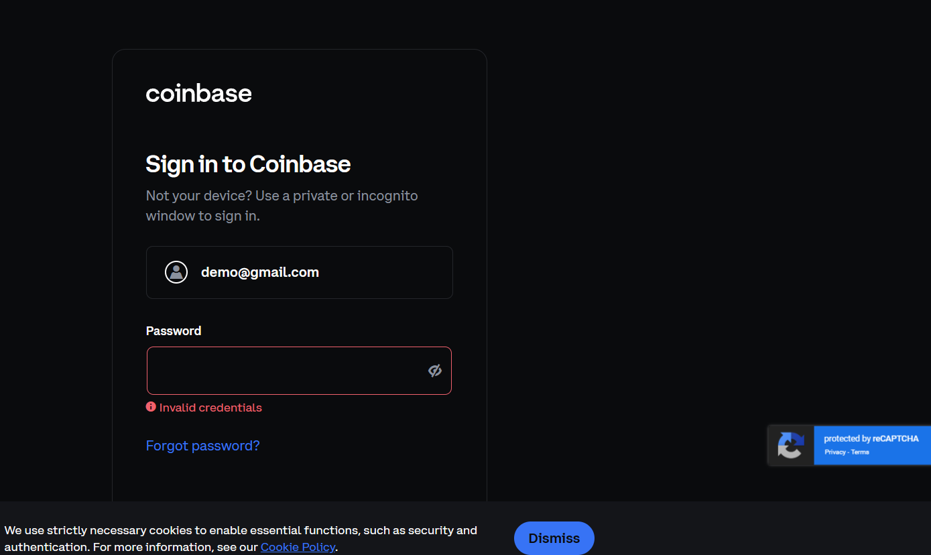

* **MyFitnessPal :**- The website is protected by reCAPTCHA, which poses a challenge for automation. Additionally, it doesn't provide clear reasons for login failures, making it difficult to determine whether the email doesn't exist or if only the password is incorrect.

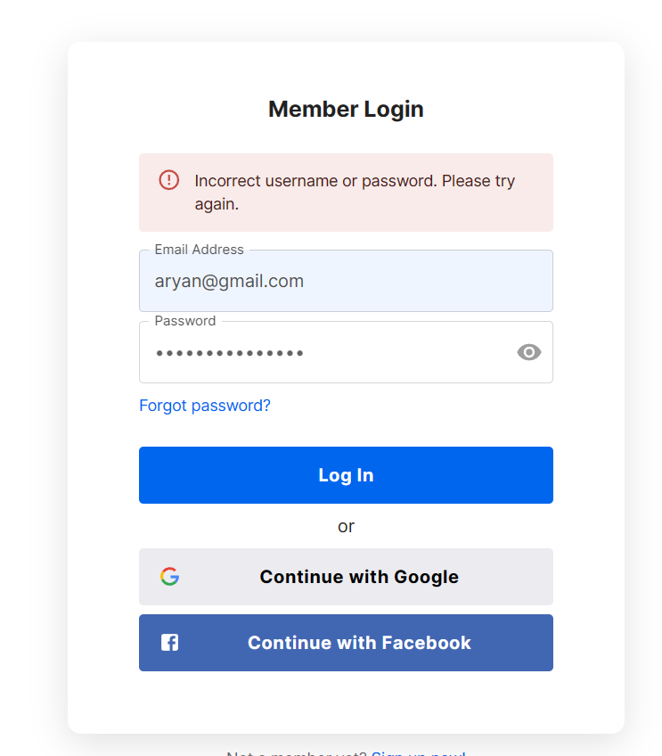

* **Pandora :**- The website doesn't provide clear reasons for login failures, making it difficult to determine whether the email doesn't exist or if only the password is incorrect & even for non-existing emails.

